|  |  |  |  |
| --- | --- | --- | --- |
| logo ngan.png | | **MINISTRY OF EDUCATION AND TRAINING** | |
| **FPT UNIVERSITY** | |
| **CAPSTONE PROJECT DOCUMENT** | |
| **BUILDING A WEBSITE SUPPORT THE ACTIVITIES “TIẾP SỨC MÙA THI” CAMPAIGN**  **Project Report #3 – System Requirements Specifications** | |
|  | |
| |  |  | | --- | --- | | **Group 22** | | | **Group Members** | |  |  | | --- | --- | | SE60769 | Nguyen Duy Khoa | | SE60687 | Le Nguyen Huu Tri | | 60358 | Nguyen Dinh Tuan | | 60325 | Tran Nguyen Kim Vinh | | 60339 | Nguyen Vinh Hien | | | **Supervisor** | Nguyen Trong Tai | | **Ext Supervisor** | N/A | | **Capstone Project Code** | TSMT | | |
| - Ho Chi Minh City, February 2014 - | |

Table of Contents

3. Software Requirement Specification 3

3.1. User Requirement Specification 3

3.1.1. Guest Requirements 3

3.1.2. Authorized User Requirements 3

3.1.3. Candidate Requirements 3

3.1.4. Charity Requirements 3

3.1.5. Volunteer Requirements 3

3.1.6. Sponsor Requirements 3

3.1.7. Admin Requirements 3

3.2. System Requirement Specification (Specific Requirements) 3

3.2.1. External Interface Requirements 3

3.2.2. Functional Requirements 3

3.2.3. Non-functional Requirements 3

3.3. Entity Relationship Diagram or Data Structure 4

3.3.1. Entity Relationship Diagram 4

3.3.2. Entity Detail 4

# SOFTWARE REQUIREMENT SPECIFICATION

## User Requirement Specification

### Guest Requirements

### Authorized User Requirements

### Candidate Requirements

### Charity Requirements

### Volunteer Requirements

### Sponsor Requirements

### Admin Requirements

## System Requirement Specification (Specific Requirements)

### External Interface Requirements

#### User Interfaces

#### Hardware Interfaces

#### System Interfaces

#### Communication Protocol

### Main Flow Overviews

### Functional Requirements

#### Overall Use case diagram

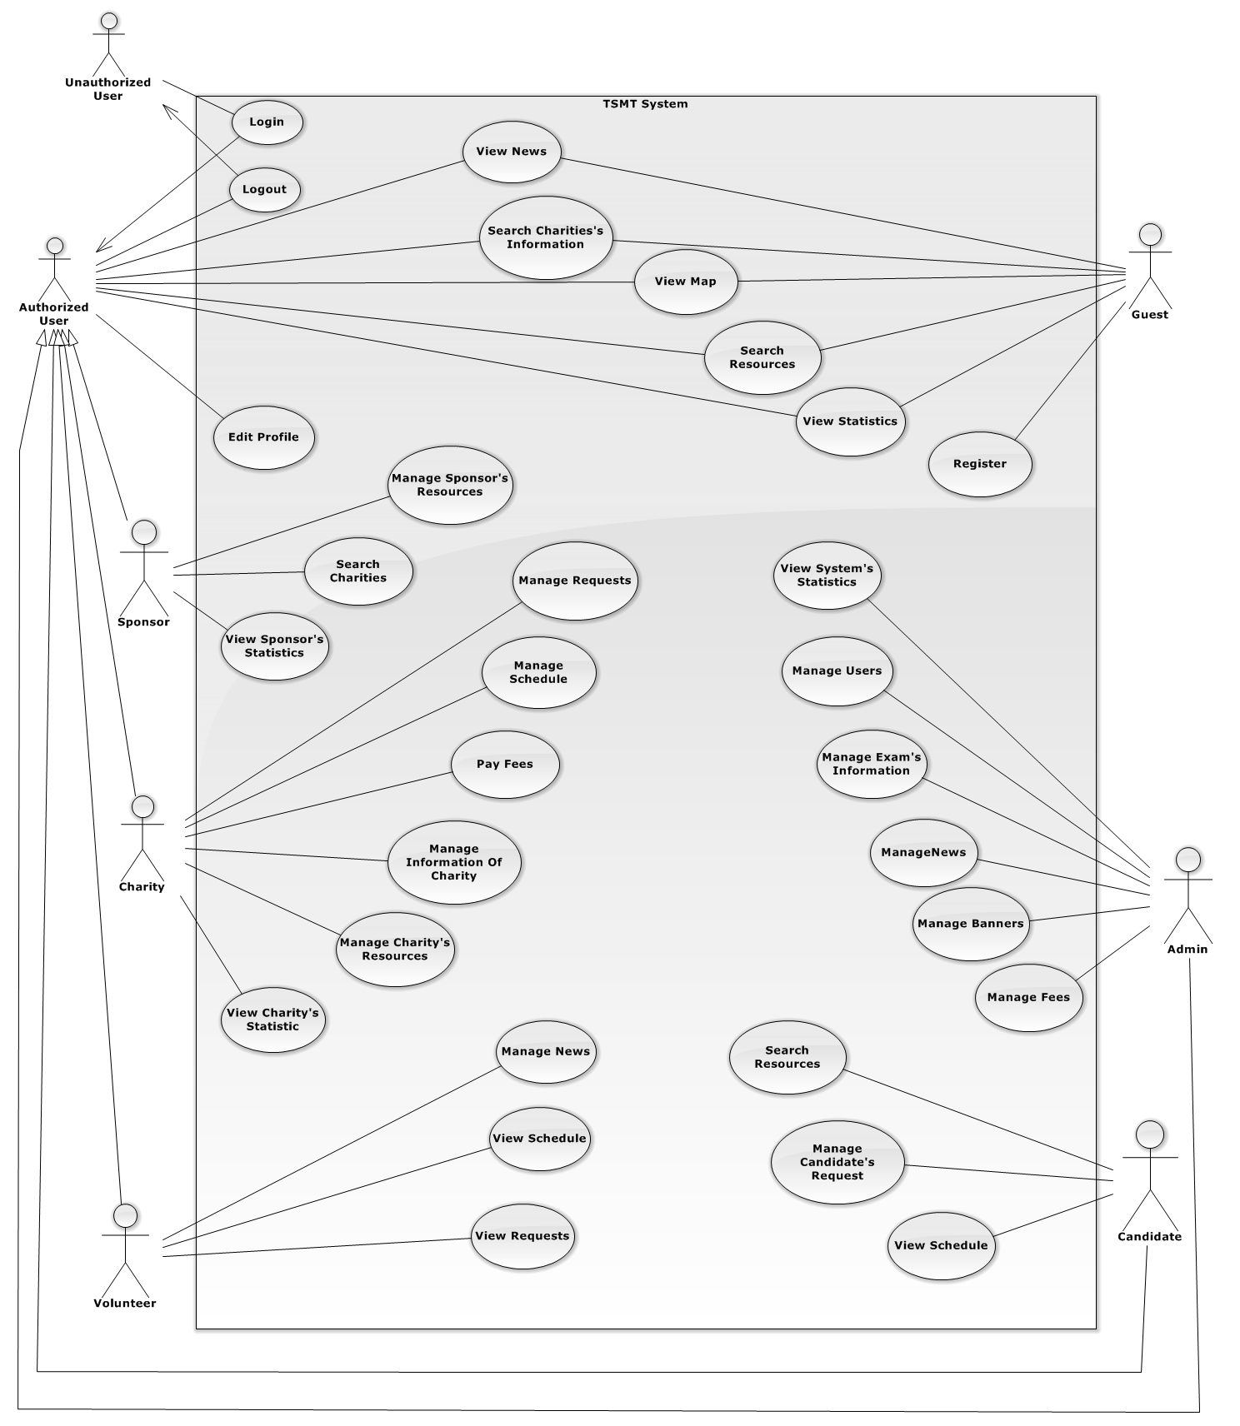

#### ⏪Unauthorized User⏩ Login

#### ⏪Authorized User⏩ View News

#### ⏪Authorized User⏩ Search Charity’s Information

#### ⏪Authorized User⏩ View Map

#### ⏪Authorized User⏩ Search Resource

#### ⏪Authorized User⏩ View Statistics

#### ⏪Authorized User⏩ Comment

#### ⏪Authorized User⏩ Edit Profile

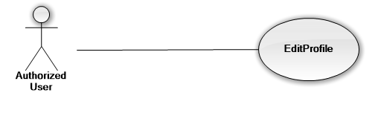

|  |  |  |  |
| --- | --- | --- | --- |
| **USE CASE-UC08 SPECIFICATION** | | | |
| **Use-case No.** | UC09 | **Use-case Version** | v1.0 |
| **Use-case Name** | Authorized User Edit Profile | | |
| **Author** | Nguyen Dinh Tuan | | |
| **Date** | 15/02/2014 | **Priority** | Normal |
| **Actor:**  Authorized User  **Summary:**  Authorized can edit the information needed, to supplement incomplete information at registration.  **Goal:**  It helps Authorized User to Edit Profile.  **Triggers**  Authorized User wants to Edit Profile.  (Authorized User click “Edit Profile” on the individual menu which has “Edit” status)  **Preconditions:**  The page is fully loaded.  User log in with “Authorized User”role.  Stay at home page.  **Post Conditions:**  Success:   * Message box show “You have to change personal information”   Failure: System displays error message. Content of error message will be specified in Exception section.  **Main Success Scenario:**   |  |  | | --- | --- | | Actor Actions | System Response | | 1. Click “Edit Profile” tab to view basic information   1. Click any line to edit information 2. Click “Update” to Update information   6. Click “OK” button to cancel update. | 2. Display a table with profile information of authorized User   * Name * Birday * Gender * Email * Address * Phone * Password   5. Show confirmation message: “Are You sure to save?” with “OK” button và “Cancel” button. [Alternative 1]  7. Close info message box, update new information and back to Home page |   **Alternative Scenario:**   |  |  | | --- | --- | | Actor Actions | System Response | | [Alternative 1]  1. Click “Cancel” button. | 2. Close info message box and back to Home page |   **Exceptions:**   |  |  | | --- | --- | | Actor Actions | System Response | |  |  |   **Relationships:**  Login,  **Business Rules:** | | | |

#### ⏪Authorized User⏩ Logout

#### ⏪Guest⏩ Register

#### ⏪Guest, Authorized User⏩ Search Charity’s Information

#### ⏪Guest, Authorized User⏩ Search Resources

#### ⏪Guest, Authorized User⏩ View Map

#### ⏪Guest, Authorized User⏩ View News

#### ⏪Guest, Authorized User⏩ View Statistics

#### ⏪Charity⏩ Manage Charity’s Information

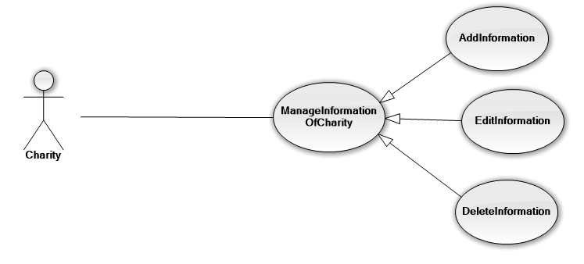

|  |  |  |  |
| --- | --- | --- | --- |
| **USE CASE-UC08 SPECIFICATION** | | | |
| **Use-case No.** | UC | **Use-case Version** | v1.0 |
| **Use-case Name** | Charity Edit Charity’s Information | | |
| **Author** | Nguyen Dinh Tuan | | |
| **Date** | 15/02/2014 | **Priority** | Normal |
| **Actor:**  Charity  **Summary:**  Charity can edit the information needed, to supplement incomplete information at registration.  **Goal:**  It helps Edit Charity’s Information.  **Triggers**  Charity wants to Edit Information.  (Authorized User click “Edit Information” on the individual menu which has “Edit” status)  **Preconditions:**  The page is fully loaded.  User log in with “Charity”role.  Stay at individual page.  **Post Conditions:**  Success:   * Message box show “You have to change information”   Failure: System displays error message. Content of error message will be specified in Exception section.  **Main Success Scenario:**   |  |  | | --- | --- | | Actor Actions | System Response | | 1. Click “Edit Information” tab to view basic information   1. Click any line to edit information 2. Click “Update” to Update information   6. Click “OK” button to cancel update. | 2. Display a table with basic information of Charity   * Organization name * Location * Day Engaged * Status * Introduction * Other activities   5. Show confirmation message: “Are You sure to save?” with “OK” button và “Cancel” button. [Alternative 1]  7. Close info message box, update new information and back to Home page |   **Alternative Scenario:**   |  |  | | --- | --- | | Actor Actions | System Response | | [Alternative 1]  1. Click “Cancel” button. | 2. Close info message box and back to Home page |   **Exceptions:**   |  |  | | --- | --- | | Actor Actions | System Response | |  |  |   **Relationships:**  Login,  **Business Rules:**  Editing with factual information | | | |

#### ⏪Charity⏩ Manage Request

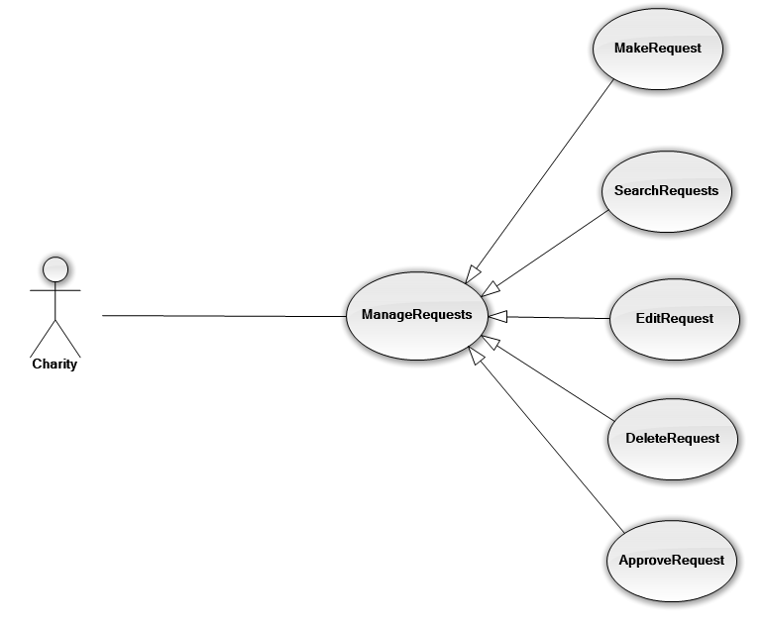

|  |  |  |  |
| --- | --- | --- | --- |
| **USE CASE-UC08 SPECIFICATION** | | | |
| **Use-case No.** | UC | **Use-case Version** | v1.0 |
| **Use-case Name** | Charity Edit Request | | |
| **Author** | Nguyen Dinh Tuan | | |
| **Date** | 15/02/2014 | **Priority** | Normal |
| **Actor:**  Charity  **Summary:**  Charity can edit Request, edit the necessary information  **Goal:**  It helps Edit Request.  **Triggers**  Charity wants to Edit Request.  (Charity click “Edit Request” on the Manage Request tab menu which has “Edit Request” status)  **Preconditions:**  The page is fully loaded.  User log in with “Charity”role.  Stay at individual page.  **Post Conditions:**  Success:   * Message box show “You have to change information of request”   Failure: System displays error message. Content of error message will be specified in Exception section.  **Main Success Scenario:**   |  |  | | --- | --- | | Actor Actions | System Response | | 1. Click “Edit Request” tab to view basic information   1. Click any line to edit Request 2. Click “Update” to Update information   6. Click “OK” button to cancel update. | 2. Display a table with basic information of Request   * Name * University registration * Code * Examinations * Lodge   5. Show confirmation message: “Are You sure to save?” with “OK” button và “Cancel” button. [Alternative 1]  7. Close info message box, update new information and back to Home page |   **Alternative Scenario:**   |  |  | | --- | --- | | Actor Actions | System Response | | [Alternative 1]  1. Click “Cancel” button. | 2. Close info message box and back to Home page |   **Exceptions:**   |  |  | | --- | --- | | Actor Actions | System Response | |  |  |   **Relationships:**  Login,  **Business Rules:**  Editing with factual information | | | |

#### ⏪Charity⏩ Manage Resource

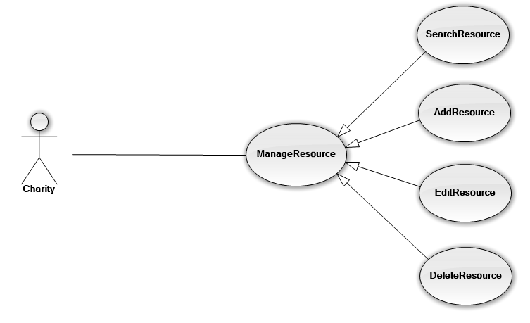

|  |  |  |  |
| --- | --- | --- | --- |
| **USE CASE-UC08 SPECIFICATION** | | | |
| **Use-case No.** | UC | **Use-case Version** | v1.0 |
| **Use-case Name** | Charity Edit Resource | | |
| **Author** | Nguyen Dinh Tuan | | |
| **Date** | 15/02/2014 | **Priority** | Normal |
| **Actor:**  Charity  **Summary:**  Charity can edit the information of resource, Editing information about the vehicle and lodge.  **Goal:**  It helps Edit Charity’s Resource.  **Triggers**  Charity wants to Edit Resource.  (Charity click “Edit Resource” on the manage Resource tab menu which has “Edit Resource” status)  **Preconditions:**  The page is fully loaded.  User log in with “Charity”role.  Stay at individual page.  **Post Conditions:**  Success:   * Message box show “You have to change information of resource”   Failure: System displays error message. Content of error message will be specified in Exception section.  **Main Success Scenario:**   |  |  | | --- | --- | | Actor Actions | System Response | | 1. Click “Edit Resource” tab to view basic information   1. Click any line to edit information 2. Click “Update” to Update information   6. Click “OK” button to cancel update. | 2. Display a table with basic information of Resource with two column   * Column Lodge * LodgeID * Address * Lodge Type * Image * Number Of Room * Male Room * Female Room * Column Vehicle * VehicleID * NumberPlate * Vehicle Type * Seat Number   5. Show confirmation message: “Are You sure to save?” with “OK” button và “Cancel” button. [Alternative 1]  7. Close info message box, update new information and back to Home page |   **Alternative Scenario:**   |  |  | | --- | --- | | Actor Actions | System Response | | [Alternative 1]  1. Click “Cancel” button. | 2. Close info message box and back to Home page |   **Exceptions:**   |  |  | | --- | --- | | Actor Actions | System Response | |  |  |   **Relationships:**  Login,  **Business Rules:**  Editing with factual information | | | |

#### ⏪Charity⏩ Manage Schedule

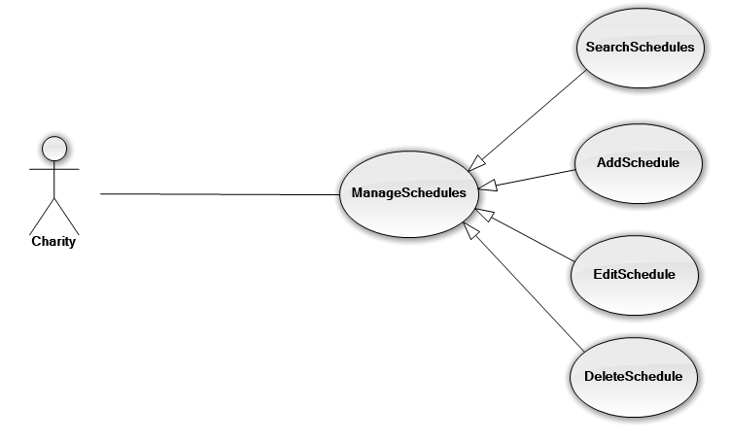

|  |  |  |  |
| --- | --- | --- | --- |
| **USE CASE-UC08 SPECIFICATION** | | | |
| **Use-case No.** | UC | **Use-case Version** | v1.0 |
| **Use-case Name** | Charity Edit Schedule | | |
| **Author** | Nguyen Dinh Tuan | | |
| **Date** | 15/02/2014 | **Priority** | Normal |
| **Actor:**  Charity  **Summary:**  Charity can edit the information of Schedule, Scheduled to pick cadidates, calendars divide a room and assign.  **Goal:**  It helps Edit Schedule.  **Triggers**  Charity wants to Edit Schedule.  (Charity click “Edit Schedule” on the manage Schedule tab menu which has “Edit Schedule” status)  **Preconditions:**  The page is fully loaded.  User log in with “Charity”role.  Stay at individual page.  **Post Conditions:**  Success:   * Message box show “You have to change information of schedule”   Failure: System displays error message. Content of error message will be specified in Exception section.  **Main Success Scenario:**   |  |  | | --- | --- | | Actor Actions | System Response | | 1. Click “Edit Schedule” tab to view basic information   1. Click any line to edit information 2. Click “Update” to Update information   6. Click “OK” button to cancel update. | 2. Display a table with basic information of Schedule   * Date and Time to pick * Exam time * Departure Time * ArrivalTime   5. Show confirmation message: “Are You sure to save?” with “OK” button và “Cancel” button. [Alternative 1]  7. Close info message box, update new information and back to Home page |   **Alternative Scenario:**   |  |  | | --- | --- | | Actor Actions | System Response | | [Alternative 1]  1. Click “Cancel” button. | 2. Close info message box and back to Home page |   **Exceptions:**   |  |  | | --- | --- | | Actor Actions | System Response | |  |  |   **Relationships:**  Login,  **Business Rules:**  Editing with factual information | | | |

#### ⏪Charity⏩ Pay Fees

#### ⏪Charity⏩ View Charity’s Statistics

#### ⏪Sponsor⏩ Manage Sponsor’s Resources

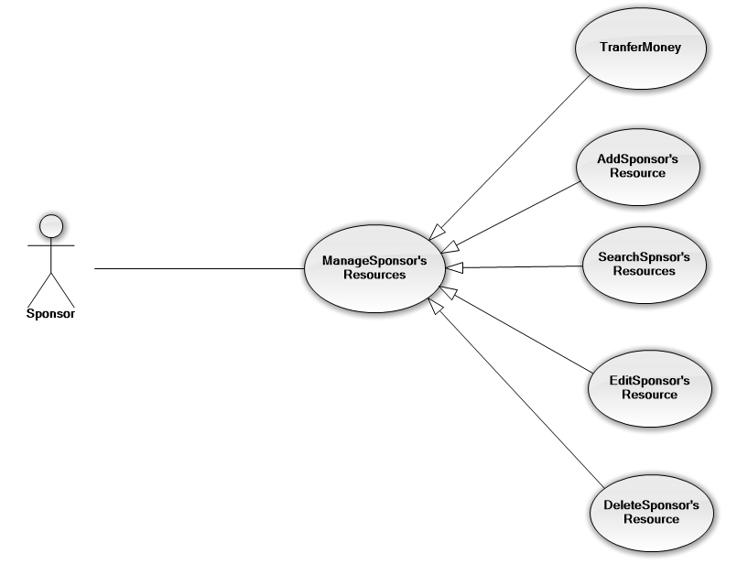

|  |  |  |  |
| --- | --- | --- | --- |
| **USE CASE-UC08 SPECIFICATION** | | | |
| **Use-case No.** | UC | **Use-case Version** | v1.0 |
| **Use-case Name** | Sponsor Edit Resource | | |
| **Author** | Nguyen Dinh Tuan | | |
| **Date** | 15/02/2014 | **Priority** | Normal |
| **Actor:**  Sponsor  **Summary:**  Sponsor can edit the information of resource, Editing information about the vehicle and lodge.  **Goal:**  It helps Edit Sponsor’s Resource.  **Triggers**  Sponsor wants to Edit Resource.  (Sponsor click “Edit Resource” on the manage Resource tab menu which has “Edit Resource” status)  **Preconditions:**  The page is fully loaded.  User log in with “Sponsor”role.  Stay at individual page.  **Post Conditions:**  Success:   * Message box show “You have to change information of resource”   Failure: System displays error message. Content of error message will be specified in Exception section.  **Main Success Scenario:**   |  |  | | --- | --- | | Actor Actions | System Response | | 1. Click “Edit Resource” tab to view basic information   1. Click any line to edit information 2. Click “Update” to Update information   6. Click “OK” button to cancel update. | 2. Display a table with basic information of Resource with two column   * Column Lodge * LodgeID * Address * Lodge Type * Image * Number Of Room * Male Room * Female Room * Column Vehicle * VehicleID * NumberPlate * Vehicle Type * Seat Number   5. Show confirmation message: “Are You sure to save?” with “OK” button và “Cancel” button. [Alternative 1]  7. Close info message box, update new information and back to Home page |   **Alternative Scenario:**   |  |  | | --- | --- | | Actor Actions | System Response | | [Alternative 1]  1. Click “Cancel” button. | 2. Close info message box and back to Home page |   **Exceptions:**   |  |  | | --- | --- | | Actor Actions | System Response | |  |  |   **Relationships:**  Login,  **Business Rules:**  Editing with factual information | | | |

#### ⏪Sponsor⏩ Search Charity

#### ⏪Sponsor⏩ View Sponsor’s Statistics

#### ⏪Volunteer⏩ Manage News

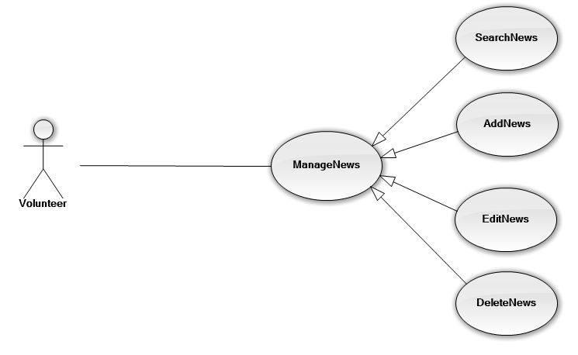

|  |  |  |  |
| --- | --- | --- | --- |
| **USE CASE-UC08 SPECIFICATION** | | | |
| **Use-case No.** | UC | **Use-case Version** | v1.0 |
| **Use-case Name** | Volunteer Edit News | | |
| **Author** | Nguyen Dinh Tuan | | |
| **Date** | 15/02/2014 | **Priority** | Normal |
| **Actor:**  Volunteer  **Summary:**  Volunteer can edit News; sort, classify posts  **Goal:**  It helps Edit News.  **Triggers**  Volunteer wants to Edit News.  (Volunteer click “Edit News” on the Manage News tab menu which has “Edit News” status)  **Preconditions:**  The page is fully loaded.  User log in with “Volunteer”role.  Stay at individual page.  **Post Conditions:**  Success:   * Message box show “You have to change information of resource”   Failure: System displays error message. Content of error message will be specified in Exception section.  **Main Success Scenario:**   |  |  | | --- | --- | | Actor Actions | System Response | | 1. Click “Edit News” tab to view basic information   1. Click any line to edit News 2. Click “Update” to Update information   6. Click “OK” button to cancel update. | 2. Display a table with basic information of News   * Name of News * Category * Content * Author * Notes   5. Show confirmation message: “Are You sure to save?” with “OK” button và “Cancel” button. [Alternative 1]  7. Close info message box, update new information and back to Home page |   **Alternative Scenario:**   |  |  | | --- | --- | | Actor Actions | System Response | | [Alternative 1]  1. Click “Cancel” button. | 2. Close info message box and back to Home page |   **Exceptions:**   |  |  | | --- | --- | | Actor Actions | System Response | |  |  |   **Relationships:**  Login,  **Business Rules:**  Editing with factual information | | | |

#### ⏪Volunteer⏩ View Request

#### ⏪Volunteer⏩ View Schedule

#### ⏪Candidate⏩ Manage Candidate’s Request

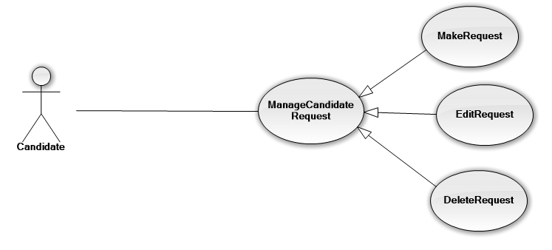

|  |  |  |  |
| --- | --- | --- | --- |
| **USE CASE-UC08 SPECIFICATION** | | | |
| **Use-case No.** | UC | **Use-case Version** | v1.0 |
| **Use-case Name** | Candidate Edit Request | | |
| **Author** | Nguyen Dinh Tuan | | |
| **Date** | 15/02/2014 | **Priority** | Normal |
| **Actor:**  Candidate  **Summary:**  Candidate can edit Request, Examinations to re-register and edit the necessary information  **Goal:**  It helps Edit Request.  **Triggers**  Candidate wants to Edit Request.  (Candidate click “Edit Request” on the Manage Request tab menu which has “Edit Request” status)  **Preconditions:**  The page is fully loaded.  User log in with “Candidate”role.  Stay at individual page.  **Post Conditions:**  Success:   * Message box show “You have to change information of request”   Failure: System displays error message. Content of error message will be specified in Exception section.  **Main Success Scenario:**   |  |  | | --- | --- | | Actor Actions | System Response | | 1. Click “Edit Request” tab to view basic information   1. Click any line to edit Request 2. Click “Update” to Update information   6. Click “OK” button to cancel update. | 2. Display a table with basic information of Request   * Name * University registration * Code * Examinations * Lodge   5. Show confirmation message: “Are You sure to save?” with “OK” button và “Cancel” button. [Alternative 1]  7. Close info message box, update new information and back to Home page |   **Alternative Scenario:**   |  |  | | --- | --- | | Actor Actions | System Response | | [Alternative 1]  1. Click “Cancel” button. | 2. Close info message box and back to Home page |   **Exceptions:**   |  |  | | --- | --- | | Actor Actions | System Response | |  |  |   **Relationships:**  Login,  **Business Rules:**  Editing with factual information | | | |

#### ⏪Candidate⏩ View Schedule

#### ⏪Candidate⏩ Search Resource

#### ⏪Admin⏩ Manage Advertising

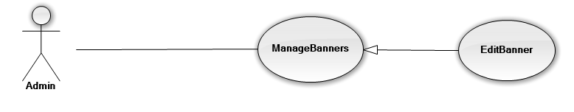

|  |  |  |  |
| --- | --- | --- | --- |
| **USE CASE-UC08 SPECIFICATION** | | | |
| **Use-case No.** | UC | **Use-case Version** | v1.0 |
| **Use-case Name** | Admin Edit Advertising | | |
| **Author** | Nguyen Dinh Tuan | | |
| **Date** | 15/02/2014 | **Priority** | Normal |
| **Actor:**  Admin  **Summary:**  Admin can edit Advertising, Change the new information  **Goal:**  It helps Edit Advertising  **Triggers**  Admin wants to Edit Advertising.  (Admin click “Edit Advertising” on the Manage Banner tab menu which has “Edit Advertising” status)  **Preconditions:**  The page is fully loaded.  User log in with “Admin”role.  Stay at individual page.  **Post Conditions:**  Success:   * Message box show “You have to change information of request”   Failure: System displays error message. Content of error message will be specified in Exception section.  **Main Success Scenario:**   |  |  | | --- | --- | | Actor Actions | System Response | | 1. Click “Edit Advertising” tab to view basic information   * + 1. Click any line to edit Request     2. Click “Update” to Update information   6. Click “OK” button to cancel update. | 2. Display a table with basic information of Advertising   * Name of banner * Rent time * Place to advertise   5. Show confirmation message: “Are You sure to save?” with “OK” button và “Cancel” button. [Alternative 1]  7. Close info message box, update new information and back to Home page |   **Alternative Scenario:**   |  |  | | --- | --- | | Actor Actions | System Response | | [Alternative 1]  1. Click “Cancel” button. | 2. Close info message box and back to Home page |   **Exceptions:**   |  |  | | --- | --- | | Actor Actions | System Response | |  |  |   **Relationships:**  Login,  **Business Rules:**  Editing with factual information | | | |

#### ⏪Admin⏩ Manage Exam’s Information

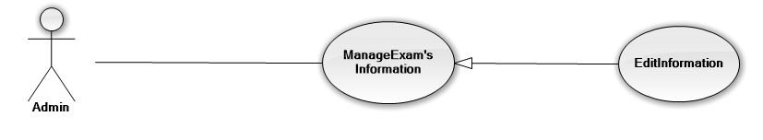

|  |  |  |  |
| --- | --- | --- | --- |
| **USE CASE-UC08 SPECIFICATION** | | | |
| **Use-case No.** | UC | **Use-case Version** | v1.0 |
| **Use-case Name** | Admin Edit Exam’s Information | | |
| **Author** | Nguyen Dinh Tuan | | |
| **Date** | 15/02/2014 | **Priority** | Normal |
| **Actor:**  Admin  **Summary:**  Admin can edit Exam’s Information, execution time, the list of universities  **Goal:**  It helps Edit Exam’s Information  **Triggers**  Admin wants to Edit Exam’s Information.  (Admin click “Edit Exam’s Information” on the Manage Exam’s Information tab menu which has “Edit Exam’s Information” status)  **Preconditions:**  The page is fully loaded.  User log in with “Admin”role.  Stay at individual page.  **Post Conditions:**  Success:   * Message box show “You have to change information of request”   Failure: System displays error message. Content of error message will be specified in Exception section.  **Main Success Scenario:**   |  |  | | --- | --- | | Actor Actions | System Response | | 1. Click “Edit Exam’s Information” tab to view basic information   1. Click any line to edit Exam’s Information 2. Click “Update” to Update information   6. Click “OK” button to cancel update. | 2. Display a table with basic information of Advertising   * Exam * Exam day * Universities list * Exam location   5. Show confirmation message: “Are You sure to save?” with “OK” button và “Cancel” button. [Alternative 1]  7. Close info message box, update new information and back to Home page |   **Alternative Scenario:**   |  |  | | --- | --- | | Actor Actions | System Response | | [Alternative 1]  1. Click “Cancel” button. | 2. Close info message box and back to Home page |   **Exceptions:**   |  |  | | --- | --- | | Actor Actions | System Response | |  |  |   **Relationships:**  Login,  **Business Rules:**  Editing with factual information | | | |

#### ⏪Admin⏩ Manage News

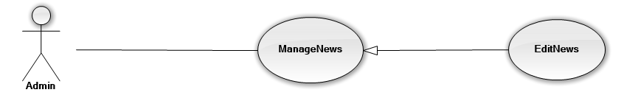

|  |  |  |  |
| --- | --- | --- | --- |
| **USE CASE-UC08 SPECIFICATION** | | | |
| **Use-case No.** | UC | **Use-case Version** | v1.0 |
| **Use-case Name** | Admin Edit News | | |
| **Author** | Nguyen Dinh Tuan | | |
| **Date** | 15/02/2014 | **Priority** | Normal |
| **Actor:**  Admin  **Summary:**  Admin can edit News; sort, classify posts  **Goal:**  It helps Edit News.  **Triggers**  Admin wants to Edit News.  (Admin click “Edit News” on the Manage News tab menu which has “Edit News” status)  **Preconditions:**  The page is fully loaded.  User log in with “Admin”role.  Stay at individual page.  **Post Conditions:**  Success:   * Message box show “You have to change information of resource”   Failure: System displays error message. Content of error message will be specified in Exception section.  **Main Success Scenario:**   |  |  | | --- | --- | | Actor Actions | System Response | | 1. Click “Edit News” tab to view basic information   1. Click any line to edit News 2. Click “Update” to Update information   6. Click “OK” button to cancel update. | 2. Display a table with basic information of News   * Name of News * Category * Content * Author * Notes   5. Show confirmation message: “Are You sure to save?” with “OK” button và “Cancel” button. [Alternative 1]  7. Close info message box, update new information and back to Home page |   **Alternative Scenario:**   |  |  | | --- | --- | | Actor Actions | System Response | | [Alternative 1]  1. Click “Cancel” button. | 2. Close info message box and back to Home page |   **Exceptions:**   |  |  | | --- | --- | | Actor Actions | System Response | |  |  |   **Relationships:**  Login,  **Business Rules:**  Editing with factual information | | | |

#### ⏪Admin⏩ Manage User

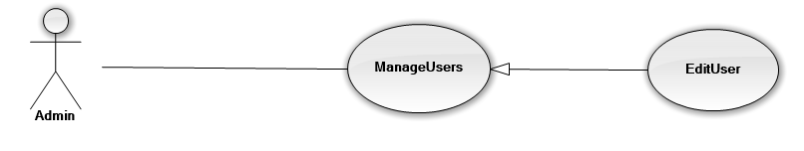

|  |  |  |  |
| --- | --- | --- | --- |
| **USE CASE-UC08 SPECIFICATION** | | | |
| **Use-case No.** | UC | **Use-case Version** | v1.0 |
| **Use-case Name** | Admin Edit User | | |
| **Author** | Nguyen Dinh Tuan | | |
| **Date** | 15/02/2014 | **Priority** | Normal |
| **Actor:**  Admin  **Summary:**  Admin can edit User; change role of user,  **Goal:**  It helps Edit User.  **Triggers**  Admin wants to Edit User  (Admin click “Edit User” on the Manage user tab menu which has “Edit User” status)  **Preconditions:**  The page is fully loaded.  User log in with “Admin”role.  Stay at individual page.  **Post Conditions:**  Success:   * Message box show “You have to edit user ”   Failure: System displays error message. Content of error message will be specified in Exception section.  **Main Success Scenario:**   |  |  | | --- | --- | | Actor Actions | System Response | | 1. Click “Edit User” tab to view basic information   * + - 1. Click any line to edit News  1. Click “Update” to Update information   6. Click “OK” button to cancel update. | 2. Display a table with basic information of News   * Name * Birday * Gender * Email * Address * Phone * Role   5. Show confirmation message: “Are You sure to save?” with “OK” button và “Cancel” button. [Alternative 1]  7. Close info message box, update new information and back to Home page |   **Alternative Scenario:**   |  |  | | --- | --- | | Actor Actions | System Response | | [Alternative 1]  1. Click “Cancel” button. | 2. Close info message box and back to Home page |   **Exceptions:**   |  |  | | --- | --- | | Actor Actions | System Response | |  |  |   **Relationships:**  Login,  **Business Rules:**  Editing with factual information | | | |

#### ⏪Admin⏩View System Statistics

### Non-functional Requirements

#### Reliability

#### Availability

#### Security

#### Maintainability

#### Portability

#### Performance

## Entity Relationship Diagram or Data Structure

### Entity Relationship Diagram

### Entity Detail